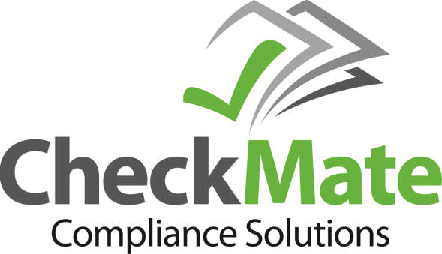

About CheckMATE Compliance Solutions
CheckMATE Compliance Solutions is comprised of therapy providers, healthcare compliance experts, IT specialists and financial consultants that are positioned to assist you in regulatory compliance and other key areas of the backroom operation of your practice including unique products and services essential to rehab providers. Services include electronic clinical record review and consultation, utilization review, regulatory compliance, payroll, tax and accounting services, reporting and consultation. Products include a state-of-the art software product that aids and assists in chart documentation audits and other key compliance components, as well as products that help to minimize overhead cost.
What Solution(s) Does Innovative Business Management Solutions Offer
The foundation of CheckMATE is the development of an electronic Chart Review application that promotes an effective, efficient audit tool. The software is customizable to meet the documentation needs and requirements of virtually any payer. It also allows for modification of the risk scoring values to satisfy your company’s documentation risk appetite requirements based on your risk analysis. The summary reporting section identifies strengths and weaknesses of the various sections of the review as well as an overall score. This scoring system helps to identify those areas a therapist needs to improve, where they excel and produces a progression chart to monitor these scores over time. The data collected does not contain PHI and is stored in the cloud for ease of accessibility from virtually anywhere. The software also assists with Risk Analysis, HiTECH compliance, asset management and an electronic compliance checklist that organizes and confirms regulatory compliance.
What Makes Innovative Business Solutions Unique
The staff of CheckMATE has been practicing in the rehab industry for over 25 years. As a small provider we have been directly impacted by the evolving compliance and regulatory requirements and are intimately aware of the resources needed to comply and survive in this industry. From these experiences we have been able to create the tools and provide services that not only assist providers in surviving but help them to thrive.

For more information contact:
Contact: Dennis Venvertloh, CPA CHC
Phone: (217)430-1318
Email: denven3@sbcglobal.net

Contact: Kathy Venvertloh, PTA CHC
Phone: (217)430-3113
Email: katven8@sbcglobal.net

